

**PROTOCOL**to exercise

***Electromagnetic Compability***

|  |  |  |
| --- | --- | --- |
| Class | Secretary | Signature |
| **4BHELS** | **HOFSTÄTTER A.** |  |
| Exercise- / Delivery date | Employee | Signature |
| 25th February 2015 |  |  |
| Teacher | Employee | Signature |
| GRASINGER |  |  |
| Grade | **Employee** | Signature |
|  |  |  |
| ***Electromagnetic Compability*** | | |
| **Used Devices**   |  |  |  |  |  | | --- | --- | --- | --- | --- | | Nr. | Device | Manufacturer | Type |  | | 1. | **Oscilloscope** | **-** |  |  | | 2. | **Function generator** | **-** |  |  | | | |

Inhalt

2 General Information 3

3 Exercise A 3

3.1 Measurements 3

3.1.1 Measurement Table 3

3.1.2 Measurement Graph 3

4 Exercise B 4

4.1 Measurement of the disturbance voltage (No resistor) 4

4.2 Measurement of the disturbance voltage (10 MΩ) 4

4.3 Measurement of the disturbance voltage (100 kΩ) 5

4.4 Measurement of the disturbance voltage (10 kΩ) 5

4.5 Measurement of the disturbance voltage (50 Ω) 6

# General Information

The task of this laboratory exercise was to distribute 230V power on two wires of a cable and then measuring the influence on unconnected wires in the same cable. This influence is called disturbance voltage.

# Exercise A

The task in exercise "a" was to measure the symmetric disturbance voltage depending on the terminating resistance.

## Measurements

### Measurement Table

|  |  |
| --- | --- |
| R [Ohm] | U [mV] |
| 10000000 | 141 |
| 1000000 | 92 |
| 100000 | 38 |
| 10000 | 7 |
| 1000 | 3 |
| 50 | 3 |

### Measurement Graph

Note: The disturbance voltage was measured with a Multimeter depending on the terminating resistance. This can be seen in the chart above. The value from the resistor went from 10MOhm down to 50Ohm. With the values of the chart a diagram was created as can be seen above.

# Exercise B

The task in "exercise b" was to measure the asymmetric disturbance voltage depending on the terminating resistance against ground. For that, 4 different resistors where used to determine the disturbance voltage and once it was measured without a resistor. The values of the resistors where 10M, 100k, 10k and 50 Ω. The disturbance voltages where measured and documented with an oscilloscope.

## Measurement of the disturbance voltage (No resistor)

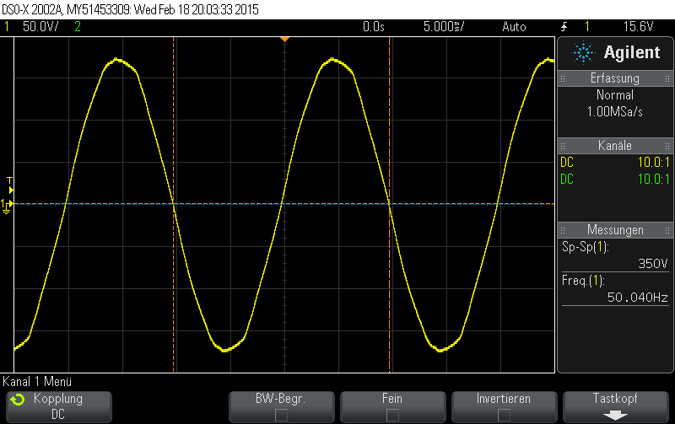

Note: On the first picture the disturbance voltage can be seen, as it was measured without an resistor.

## Measurement of the disturbance voltage (10 MΩ)

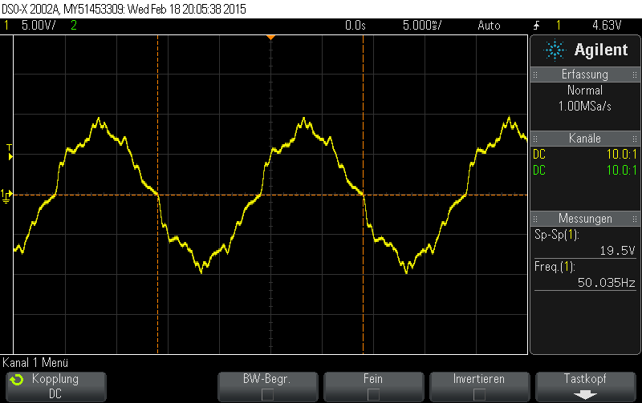

Note: On the second picture the disturbance voltage was measured with a 10MOhm resistor against ground.

## Measurement of the disturbance voltage (100 kΩ)

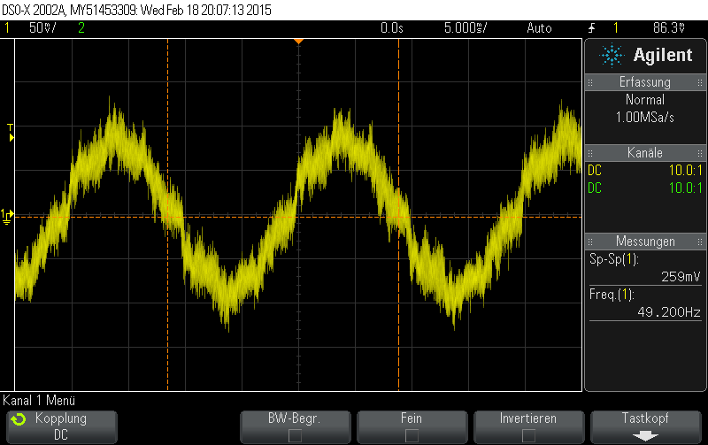

Note: Here the disturbance voltage was measured with a resistor of 100kOhm.

## Measurement of the disturbance voltage (10 kΩ)

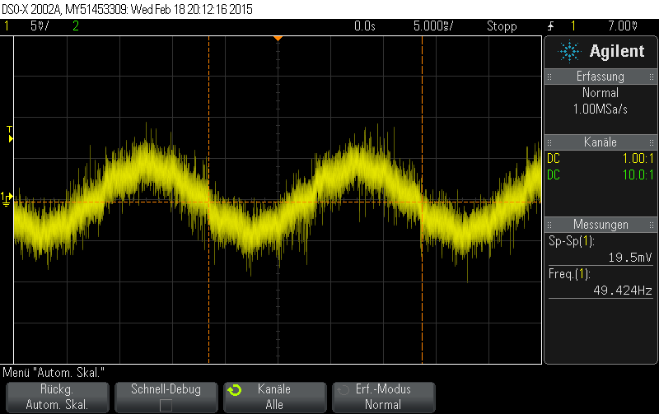

Note: On this picture a resistor with a value of 10kOhm was used to measure the disturbance voltage.

## Measurement of the disturbance voltage (50 Ω)

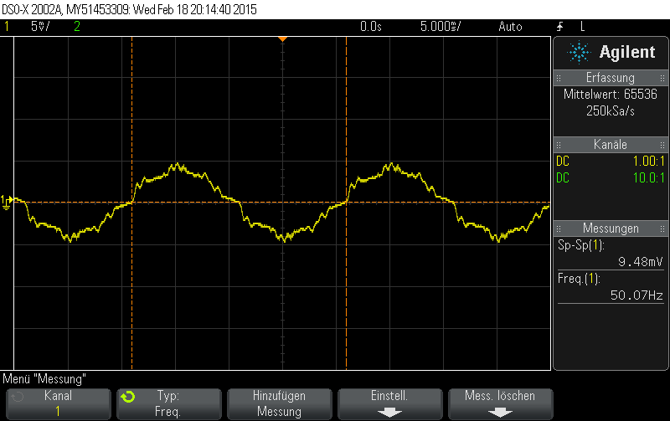

Note: Finally on the last picture the disturbance voltage was measured with the help of a terminal resistor of 50Ohm.